**JAVA FUNDAMENTALS: ALICE-3**

* **B.RISHITHA**

**192324130**

**2_1 PRACTICE:**

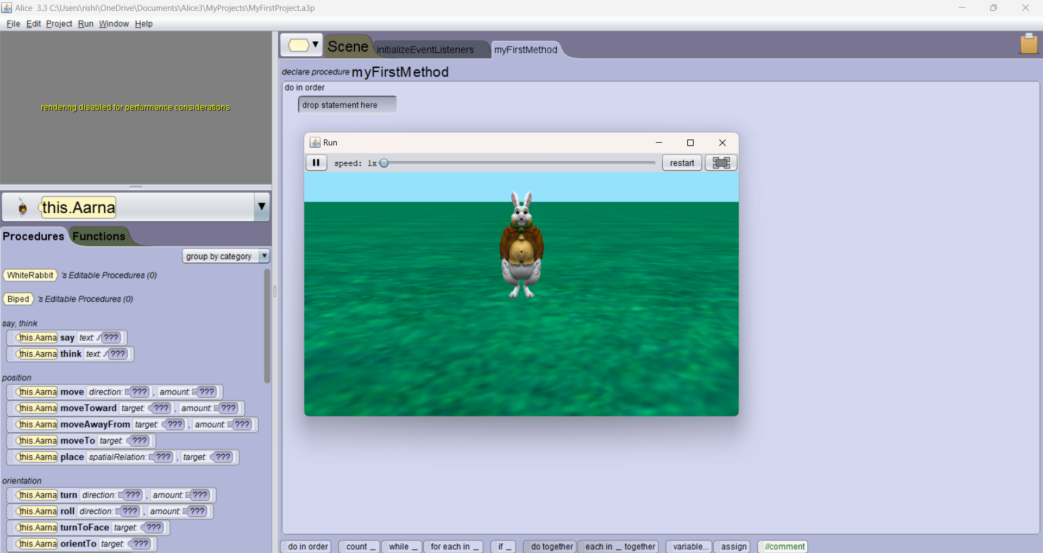

**2_1 PROJECT:**

